Computer Vision

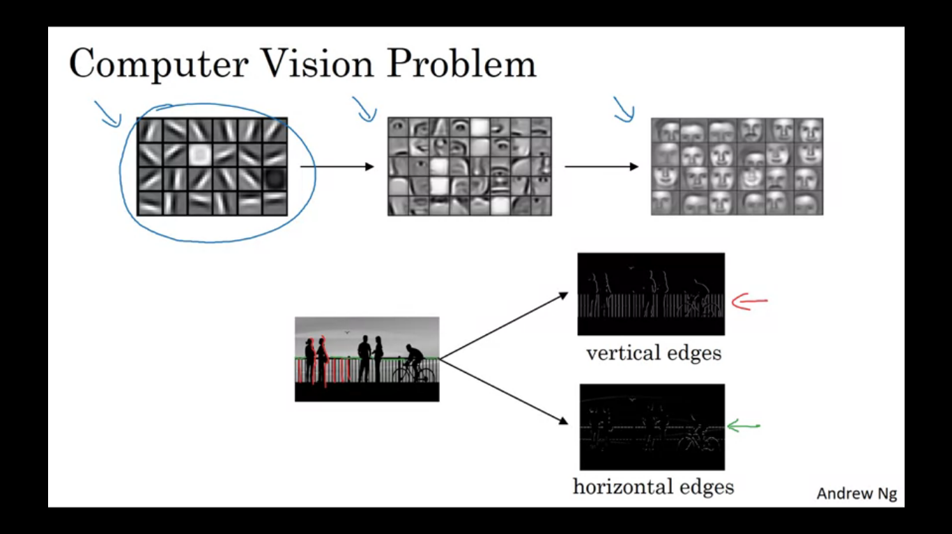

Rapid advances in computer vision are enabling brand new applications to view that were impossible a few years ago. Applications of computer vision include image classification, object detection (as in case of self driving cars we need to figure out the position of other cars). In object detection we also have to draw boxes around them. Another example includes Neural Style Transfer. In this you have a content image and a style mage and NN can put them together to repaint the content image but in the style of the style image.

**Challenges of computer vision**

Inputs can get really big. Previously we have worked with 64X64X3 images which in total is 12288 total input features to be fed to NN. If we work with a larger image like 1000X1000X3 that is actually just one megapixel the dimensions input features will be 1000*1000*3. So input vector X is a 3 million dimensional vector and if the first hidden layer has 1000 units then the number of weights W1 will be 1000X3million dimension matrix making the total parameters as 3 billion.

**Edge Detection**

Using Edge detection you will see how convolution operation works. Earlier layers detect edges whereas later layers detect parts of objects.

Given an example image as shown and to detect images, the first thing we might do is to detect the vertical edges in this image and also the horizontal edges.

**How do we detect objects in an image?**

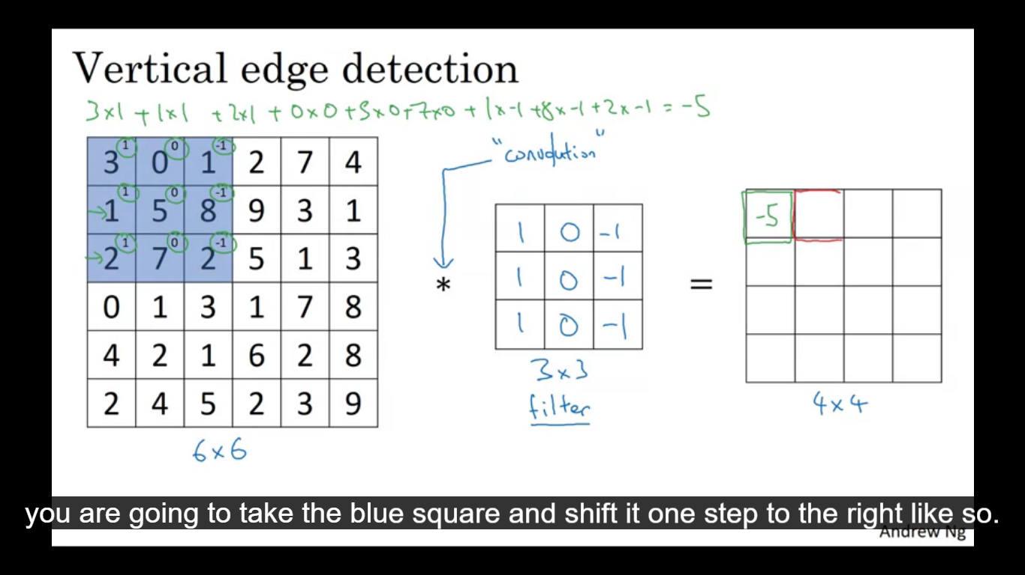

Example image is a 6X6 matrix and since it is a gray scale image it has total dimensions of 6X6X1. In order to detect edges, what we do is construct a 3X3 matrix, in terminology of CNN this is called a filter. The output of this convolution operation would be the 4X4 matrix. To compute this 4X4 image it is done in the image. Put the filter on the image and take the element wise product.

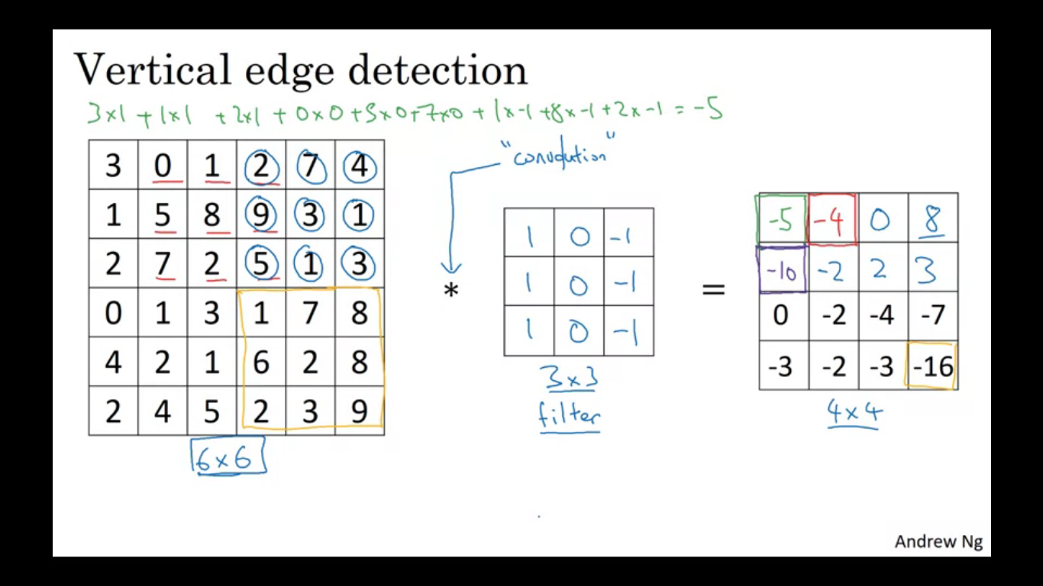

**Why is it doing vertical edge detection?**

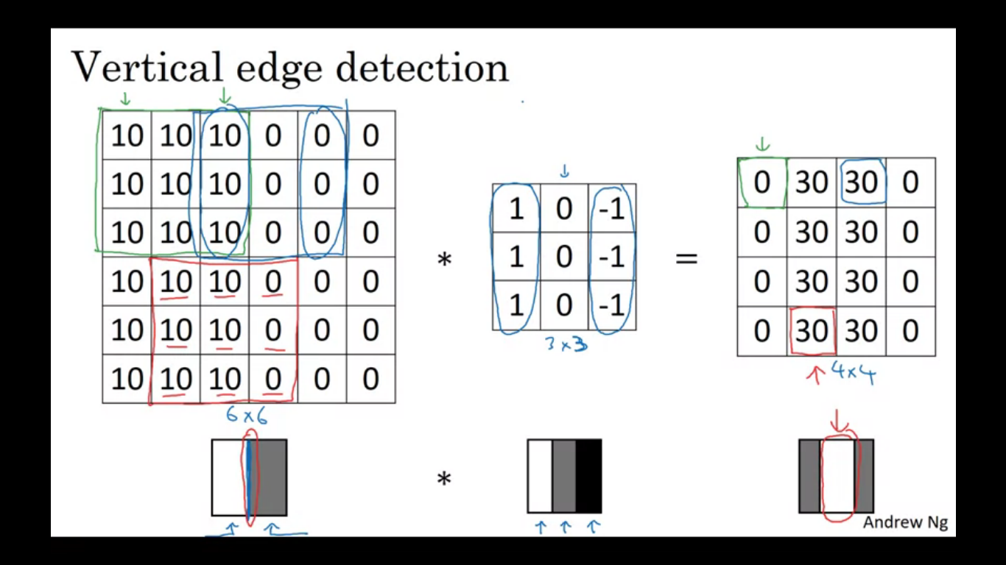

10 represents brighter pixel so in this image there is a clear transition from white to dark colour. Brighter in the middle suggested that there might be a strong vertical edge separating the both. Vertical edge is a 3X3 pixel where we have bright pixel on the left and darker pixel in middle and darkest pixel in the end. Convolution operation gives us a convenient way to specify how to find these vertical edges in an image.

**Difference between positive and negative edges**

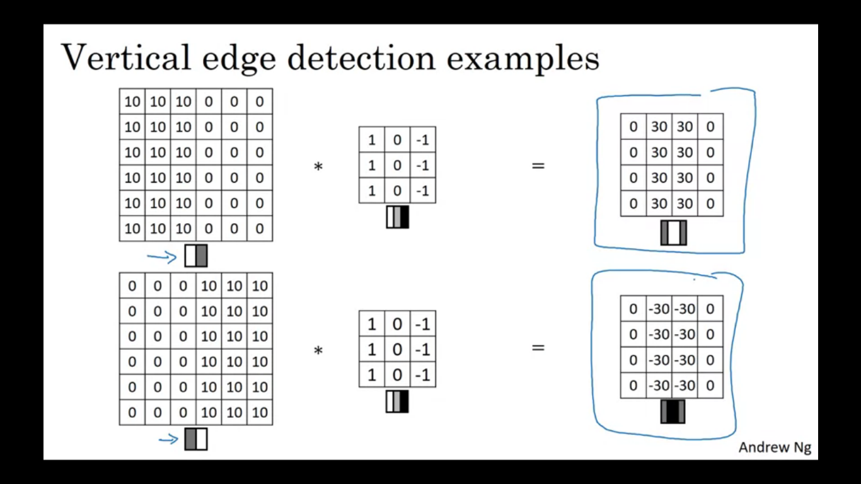

That is the difference between light to dark versus dark to light transitions.

**Different filters allow you to find vertical and horizontal edges.**

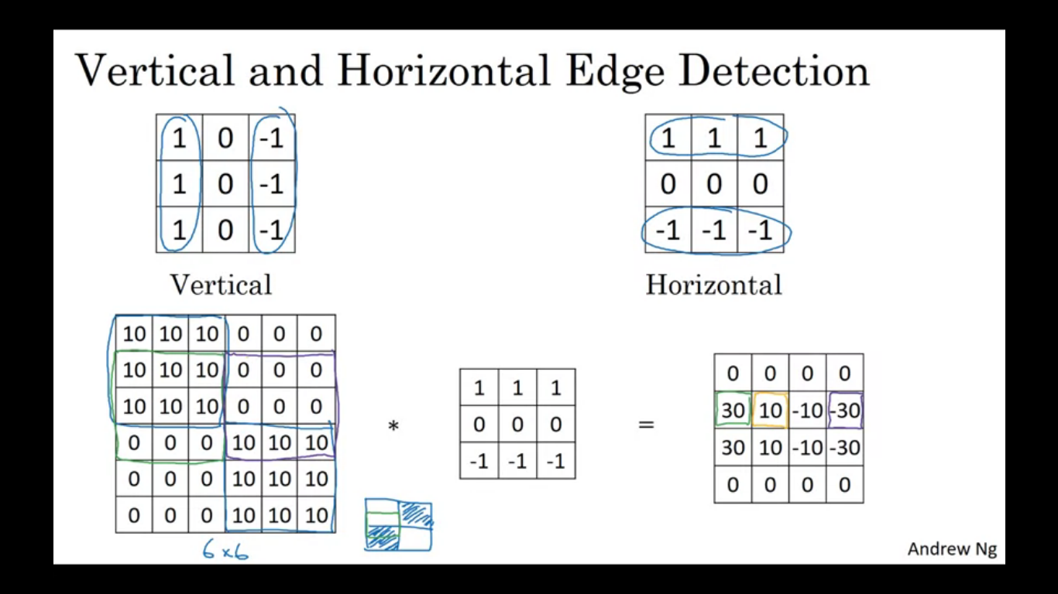

The filter we use is just one choice. Historically there was a huge debate about what numbers to choose. So we can choose what is called as a sobel filter, which puts a little more weight to the central row, or a scharr filter. These are for vertical edge detection, if we flip it 90 degrees we get horizontal edge detection. We can also treat the numbers in the filters as parameters which we can learn through back propagation.

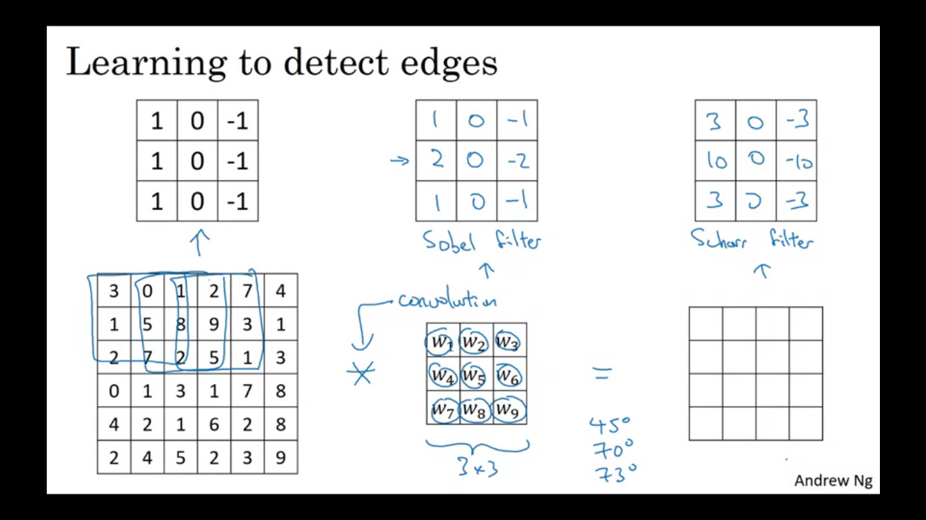

Formula

nxn image convolved with fxf filter , so it will give an output image of size n-f+1.

**Padding**

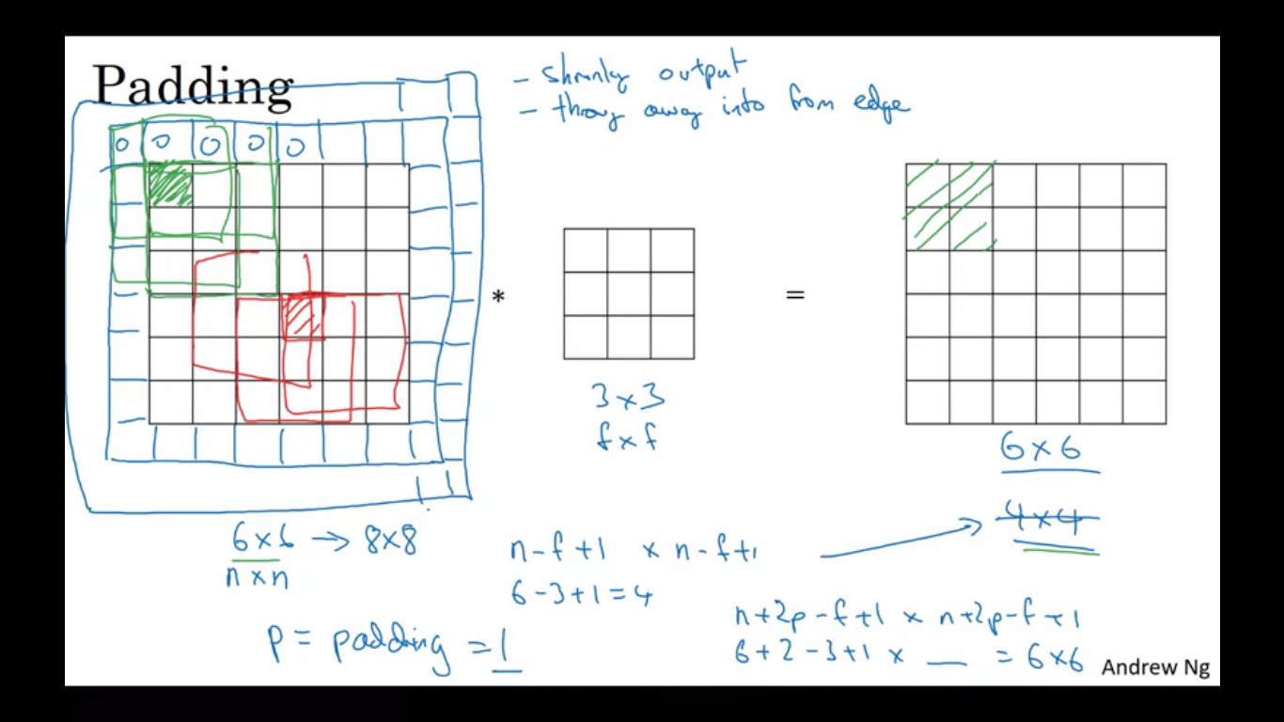

Every time you apply a convolution operation, the image shrinks. The corner pixel is touched as used only in one of the outputs. The other pixels have a lot of regions where they overlap, so it is as if pixels in the corner are used much less in the output. To solve both of the above mentioned problems: before applying conv operation, pad the image with an additional border. So instead of 6x6 image now the image is 8x8, so after conv we get a 6x6 image as output.

By convention we pad the image with zeros, if p is the padding amount, then the output size becomes n+2p-f+1.

How much to pad comes with two convolution choices – valid conv and same conv

Valid conv basically means no padding (n-f+1)

Same convolution means pad in a way so that the output size is the same as the input size.(n+2p-f+1)

When f is odd we can choose the padding size = (f-1)/2

By convention in computer vision f is usually odd. Because odd dimension filter has a central position and sometimes in computer vision it is nice to have a distinguishing pixel.

**Strided Convolutions**

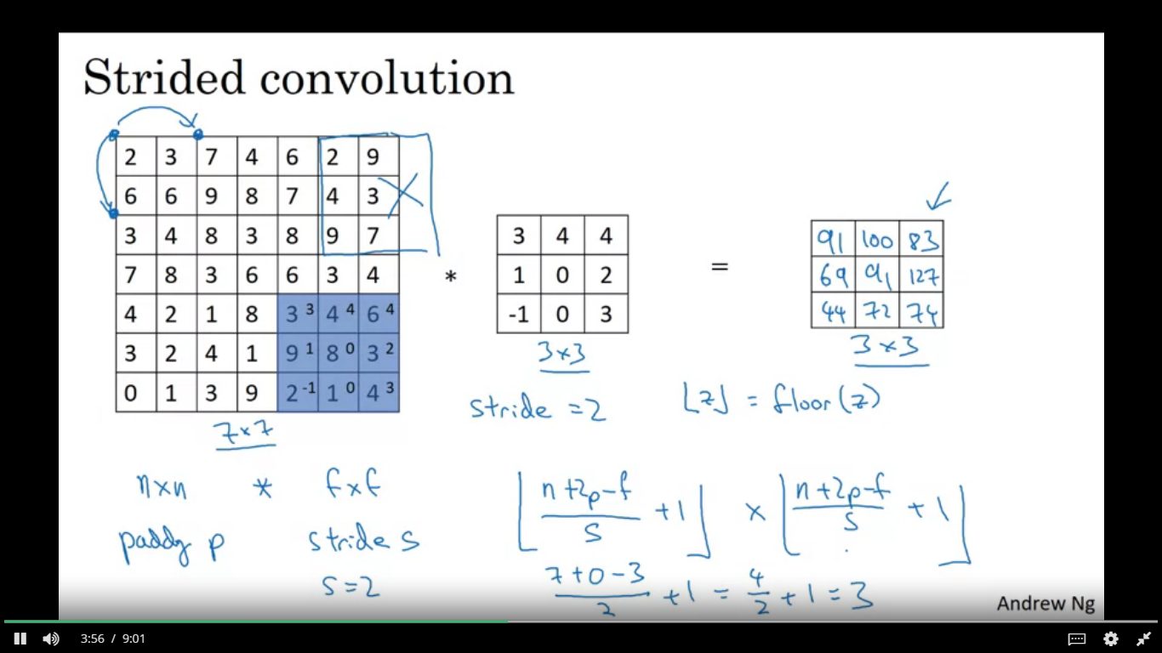

We want to find the convolutions of a 7x7 image with a 3x3 filter and with the stride of 2 to get a 3x3 output.

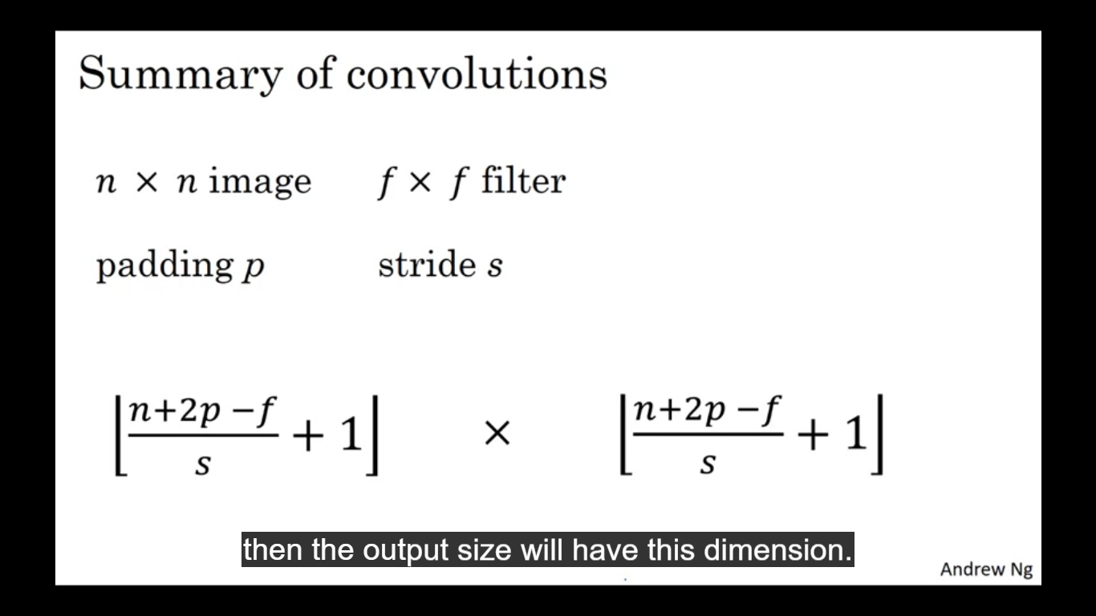

So input is nxn image convolve with fxf filter , padding p and stride s, then output is (n+2p-f)/s + 1, floor of this.

**Implementing convolutions over 3 dimensional volumes**

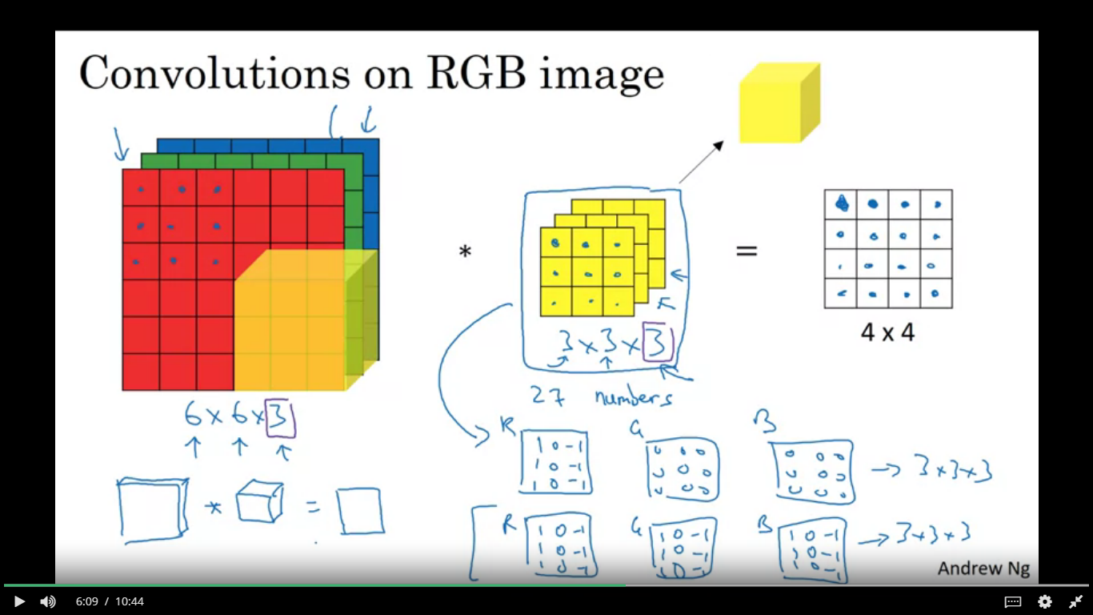

So a RGB image is 6x6x3 image where 3 here corresponds to the 3 colour channels. To convolve with ed image we now have a 3d filter. Number of channels in the image must match number of channels in the filter. The output here is though a 4x4x1 image. The filter has 27 parameters so we take each of these 27 numbers and multiply them with values with the respective values of R G and B. Then add up all those numbers and this gives you the first number in the output 4x4 image.

If we want to detect red channels in the image then we can have specific values for the red filters and different values for the green filters. Different choices for the parameters we get different feature detectors.

**What if we want to detect multiple edges?**

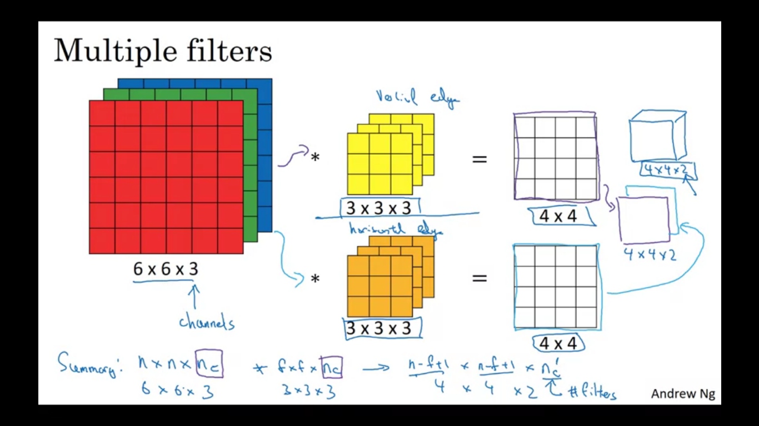

The two in the output comes from the fact that we used 2 different filters.

**Summarize the dimensions:**

**Nxnxnc * fxfxnc - > n-f+1 x n-f+1 x nc’ where nc’ is the number of filters that you use/ depth**

**One layer of a Convolutional Neural Network**

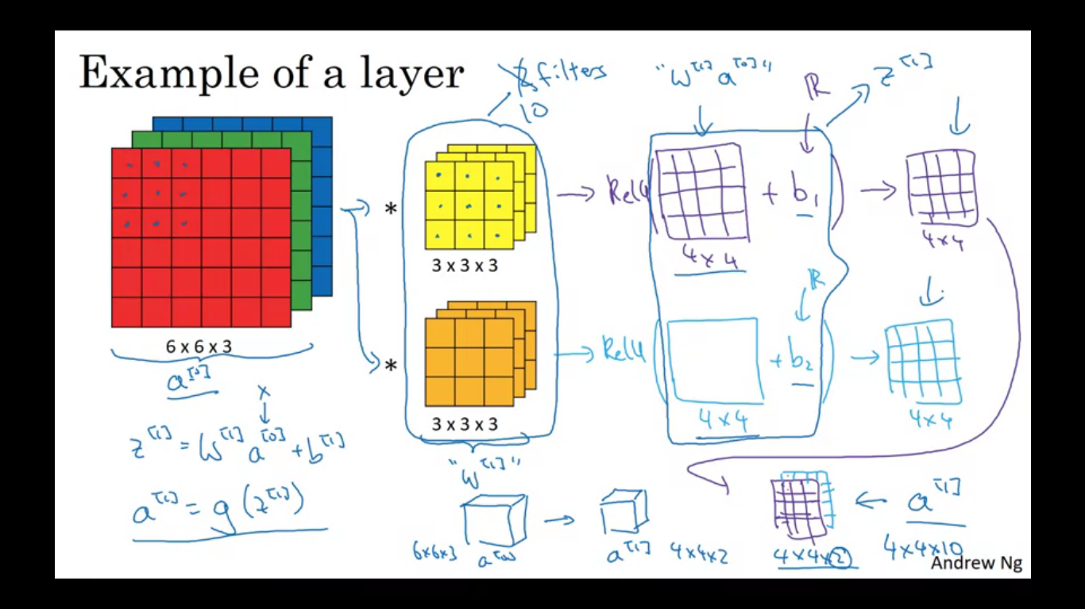

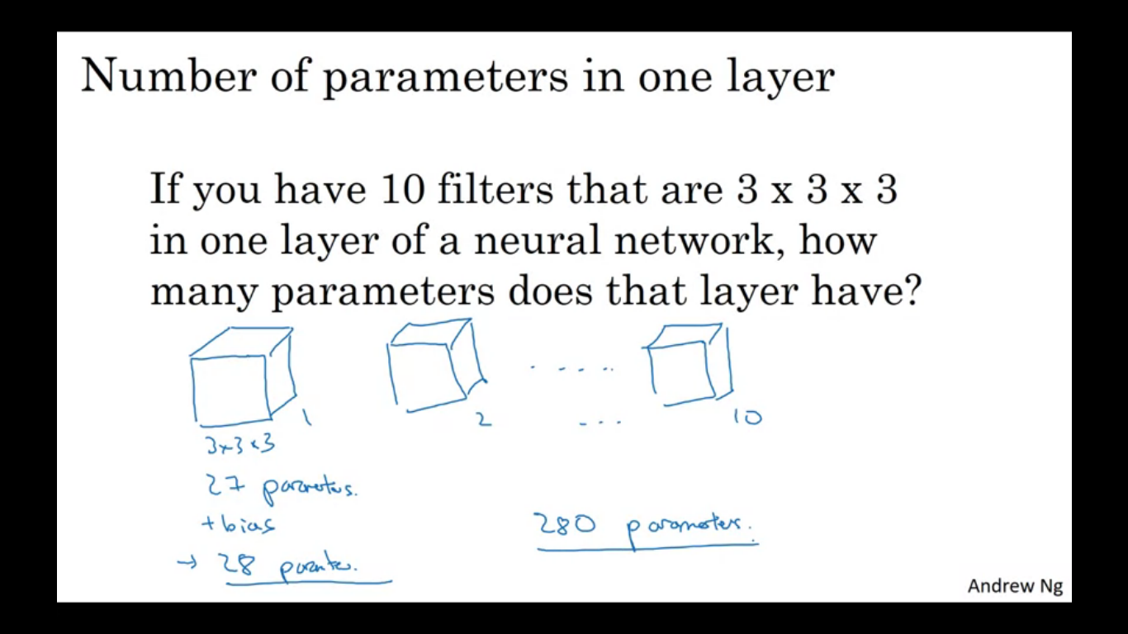

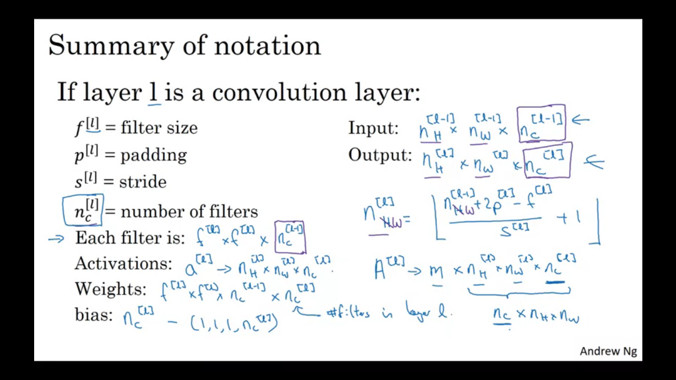

After getting the output from a previous image after convolving it over the filters, we add a bias, which is a real number and also apply non linearity we get a 4x4 output. If we stack up the outputs obtained by convolution of two filters we end up with a 4x4x2 this is one layer of a CNN. The original image is X or a[0] and these filters here play the role of w[1]. Before applying the bias plays a role of Z and after adding the bias we perform some non linearity, it becomes the activation for the enxt layer.

**Simple CNN example**

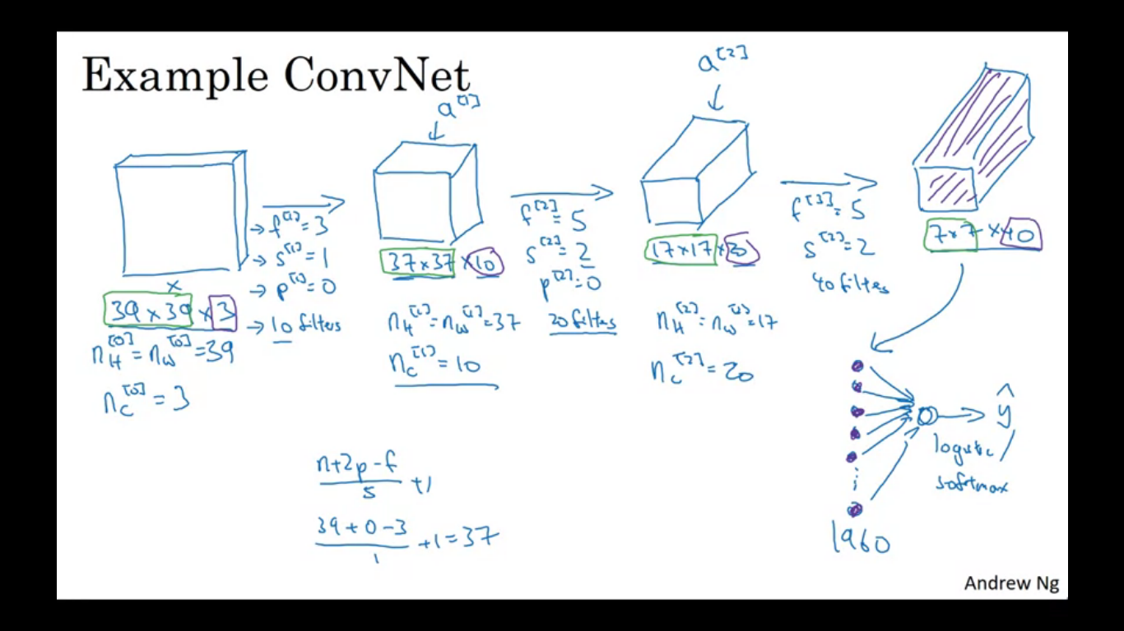

We want to do image recognition. We input an image X and decide if it is a cat or not. Input size is 39x39x3. So nh[0] = nw[0] = 39 and nc[0] = 3. The first layer uses a set of 3x3 filters to detect features. f[1] = 3, s[1] = 1, p[1] = 0, on total of 10 filters.

Activations in the next layer will be 37x37x10, 10 comes from the fact that there are 10 filters. And 37 comes from the formula (n+2p-f)/s + 1. So in the notation for this layer we have nh[1]=nw[1] =37 and nc[1] = 10. Nc[1] is equal to the number of filters from the first layer.

Another convolution layer and we have f[2] = 5,s[2] = 2,p[2] = 0 and total of 20 filters. The output of this will be 17x17x20. So nh[2] = nw[2] = 17 and nc[2] = 20

The last convolution layer f[3] = 5, s[3] = 2,p[3] = 0. Total filters are 40. The output is a 7x7x40.

Finally 7*7*40 = 1960, take this volume and flatten it into 1960 units and then feed this to a logistic regression or softmax units.

Hyper parameters to decide are what is the filter size, what is the stride, what is padding used, how many filters are used. So image size will decrease whereas number of channels may increase.

**Pooling layers**

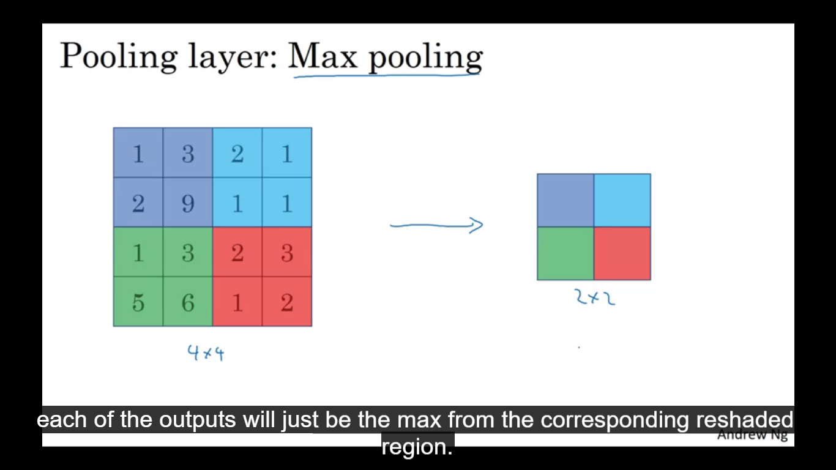

Conv nets use pooling layers to reduce the size of the representation, to speed up computation as well as make some of the features it detects a bit more robust.

4x4 input and apply maxpooling to get a 2x2 output. Hyper parameters f = 2 and s = 2. Where f is the filter size and s is the stride. Maxpooling has a set of hyper parameters but it has no parameters to learn.

**Maxpooling on a 3d input**

We perform the pooling on each of the challenges independently. Input is axaxnc then output is bxbxnc, ie the channels remain the same.

Another type of pooling is average pooling

F=2 and s=2 has the effect of shrinking the input by a factor of 2. Number of input channels is equal to the number of output channels.

Usually when people call as layers these are the layers with weights and parameters, since the pooling layer has no parameter so conv1 and pool1 are sometimes together called as layer 1

Pooling layers have no parameters, conv layers have very less parameters and a lot of parameters tend to be in the fully connected layer. Activation size goes down gradually.

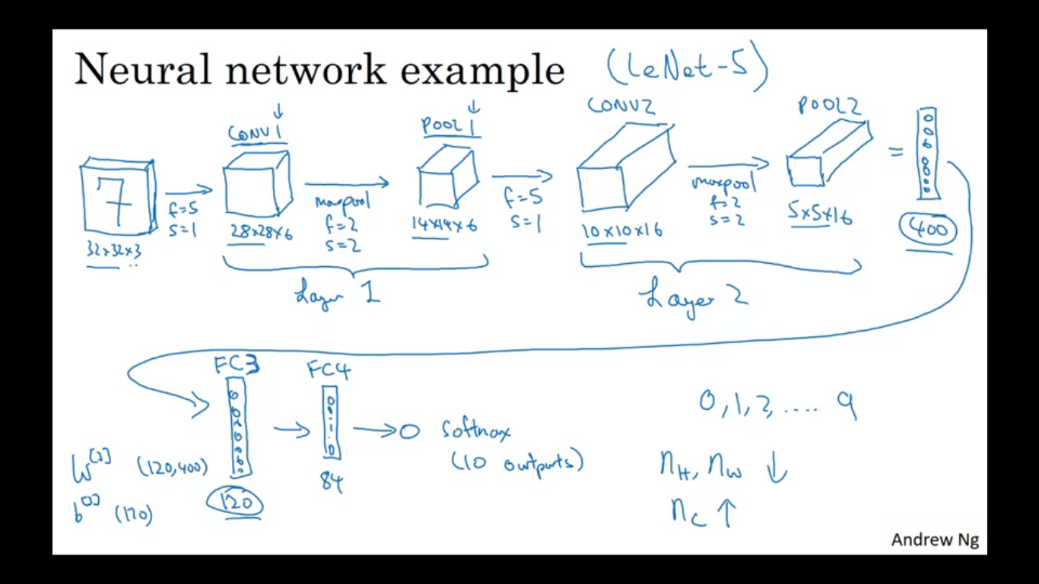

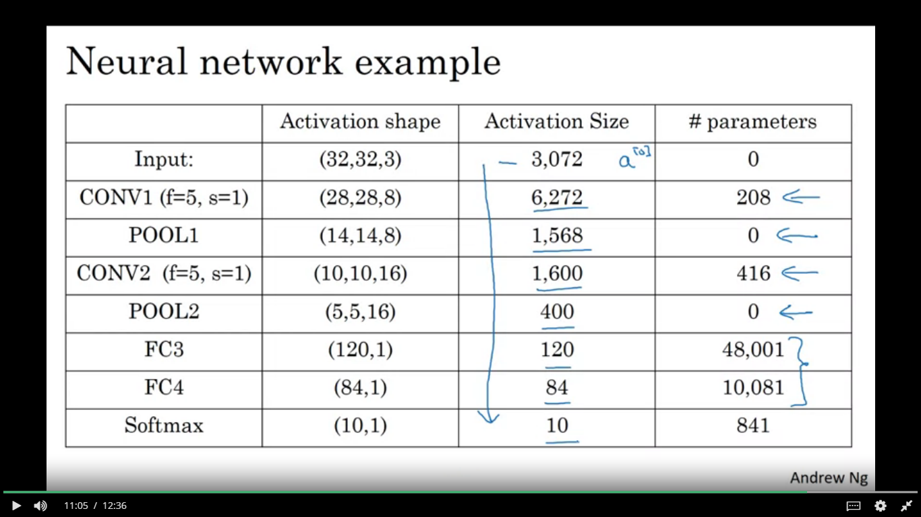

**Benefits and advantages of convolutions in a NN**

Parameter sharing and sparsity of connections

Input is 32x32x3 (3072) and f=5 number of filters=6 so output is 28x28x6 (4704). Next if we are to join these number of parameters so in our weight matrix we will have 3072 * 4704 = 14M parameters which are a bit too much for the small sized image we have used. But if we used the convolutions then the number of parameters are each filter is 5x5 = 25 + bias parameter = 26 parameters and total there are 6 filters so on total the parameters are reduced to 156.

Parameter sharing means that if a feature detector is useful for one part of image then it might be useful for another part of the image.

Sparsity of connections mean in each layer each output value depends only on a small number of inputs.